Type-C OTG Combo USB Hub + Card Reader
Enable a powerful 2-Port USB Hub with the added
convenience of a multi-functional Memory Card Reader
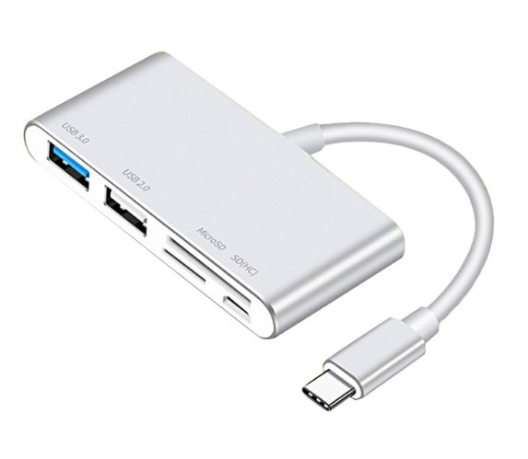

Descrption:
SuperSpeed USB 3.0 Port with USB 2.0 Port :
SuperSpeed USB 3.0 port allow you to connect USB-A peripherals (e.g. keyboards, mice or thumb drives) to a USB-C laptop and transfer data at up to 5 Gbps. Backward compatible with USB 2.0 and USB 1.1.

SD/TF Card Reader Port :
Enable you to easily access files from an SD card or a TF card on your USB-C laptop.
But Attention: The SD card slot and the TF card slot can't be used simultaneouly.

Micro USB Power Port :
Connect to a Micro USB power adapter for power supply. But attention: this port does not support to charge your device OR data transfer,it is for power supply only.

Stylish and Portable:
Thin, lightweight and compact design with the aluminum alloy exterior makes this hub a great travel companion. Easily slide it into your pocket, bag or suitcase.

Easy to Use:
No driver required. Plug and play. Support hot swapping function.
Compatible Made For:MacBook 2018/2017/2016,MacBook Pro 2018/2017,iPad Pro2018,Chromebook,HUAWEI P30/P30 Pro mate20/mate20/MateBook. pro,Samsung S10/S9/Note8/Note 9,HP Spectre Pavilion,Huawei.Matebook,Dell XPS series, ASUS ZenBook, Mi Air ….. Supports For newest Mobile phones and tablets with DP function.

Features:
- Support Type-C ports products
- USB port Hub can support mouse keyboard,flash drives and others.
- High speed data transfer with Micro SD/SD(HC)/MMC/ memory cards.
- Aluminum alloy，Excellent material, Stylish simple
- Multi-expansion, high-speed transmission
- USB 3.1 Type-C OTG COMBO.

SPECIFICATIONS
- Support：1*USB3.0 port+ 1*USB2.0 Port+ 1*SD slot+ 1* TF slot + Micro B port
- Material：Aluminum cover +plastic
- Cable： 115mm
- Certificate: CE FCC ROHS
- Operating Temperature:0℃ to +45℃
- Operating Humidity:10%0 to 85 % RH
- Storage Temperature : -10℃ to +55℃
- Storage Humidity: 5% to 90 % RH

Product Code:
- Part number: C-TC-5IN1-USB3HUBCR
- Product size: 76*36*12mm
- Barcode: 8400800040299

